Still Life with Plums by Marie Manilla Assignment
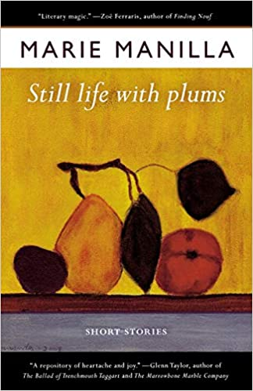   Marie Manills’s Website at https://www.mariemanilla.com/ and View of Huntington from Marshall U.
Peruse the AHWIR website for Marie Manilla, explore the links, and look at the introductory essay on Manilla under the Teaching Tools and Resources link: “Home Is Where the Heart Is, Empathy, Art, and the Fiction of Marie Manilla.” You will also learn much about Manilla and her work by reading the Interview at In Her Own Words link.

As you read the array of stories from the Still Life with Plums collection, be alert for the range of characters and ethnicities in the collection as well as superb awareness of language and the brilliant glimmers of satire as Manilla offers a scorching critique of patriarchy. Look also for commonalities among these seemingly different stories. Read the story “Hand.Me.Down,” and notice the connection this tale has with Manilla’s best-selling book The Patron Saint of Ugly. How does the father, a dark skinned Irishman, translate his anger and pain to his children, perpetuating family dysfunction? What is being handed down in this family? “Childproof” is a satire of a bridal shower and patriarchy, with unreasonable expectations foisted upon women by a misogynistic culture. What character appears to function as an antidote to this misogynistic intent? “Grooming” is a chilling portrait of a predator and pedophile, another feature of patriarchy, in the guise of an ex-fireman and community servant. What is the modus operandi of Cal, and how is he “seduced” by his own illusions? “Amnesty” is a touching story set in Guatemala, about a family at the mercy of patriarchy gone amuck. After the torcher of prison, how is Hector reconnected in some degree to his humanity by Ana, a janitor in a museum? “Distillation” is a tale about the substance of lives that can be distilled to infinite smallness, as Betty and Jeff, a couple from Texas, sort out an unhappy marital situation and family dysfunction. Why does Betty feel she must escape the toxicity of her life with Jeff and return to West Virginia? What does this story have in common with “Hand.Me.Down”?

The story “Still Life with Plums” is a wonderful satire of the University set, the fiction establishment, and book world over-brimming with sexism and self-delusion. The protagonist Natalie has traveled to attend a writer’s conference where she is the featured speaker, resting on the laurels of what she considers her one-book success story in the fiction world, her Oprah Book Club phenomenon called Mixed Metaphors. Fearing that she has “spent her lifetime allotment of words,” Natalie does her best to get through the workshop unscathed. Who is the one student that appears to stand apart from the generally self-absorbed and over-confident group of nascent writers that Natalie is addressing, and how does the literary herd treat this standout talent? What is Manilla saying about the writing world and about the university intelligentsia? “Crystal City” is a story dealing with the stain and hypocrisy of WWII interment of non-white people considered a threat by the establishment. How does this story portray the American sin of the internment camps and the fake reconciliation attempted after the dire deed was done? “The Wife You Wanted” is a brilliant dramatic monologue that in some respect is a kind of “apologia” for the Appalachian character who might eschew career, wealth, and the typical idea of success for family, home and hearth. How does the story portray a different value system from the archetypal American dream? Are places like West Virginia sometimes judged unfairly because of different cultural values, not to mention different accents and dialects? “Get Ready” provides the finale for the collection, telling the story of Sarah and Chloe, who cannot get beyond Sarah’s raison d être, which is “to run,” conditioned as she has been by a series of men who have treated her badly and to whom she has responded in like manner. Like “Counting Backward,” “Getting Ready” is a story about wrong decisions and missteps that keep human beings treading water and moving nowhere, where habit and circumstance don’t seen to allow for evolution and growth. What do all these stories Still Life with Plums have in common in terms of social constructs which determine people’s lives. Why do you think Marie Manilla called the central story and the volume itself Still Life with Plums?

